**SASS Pipeline with GULP**

**Assignment**



Session: 2021 – 2024

**Submitted by:**

Uswa Arif

2021-CS-77

**Submitted To:**

  Aatif Hussain

Department of Computer Science

**University of Engineering and Technology**

**Lahore Pakistan**

**Introduction:**

Gulp is NPM package that automates repetitive tasks in development projects. This includes tasks like compiling SASS to CSS, bundling JavaScript files, optimizing images, and more. The objective of this report is to document the step-by-step setup and configuration of a SASS pipeline using Gulp. It involves tasks such as **compilation, autoprefixing, and minification**, which are crucial for efficient web projects.

**Configuration Setting:**

The step-by-step Setup of this project using gulp is given below:

1. **Project Initialization:**

Initialize a new Node.js project by running the following command in your terminal:

“**npm init -y**”

1. **Gulp Installation:**

Gulp package can be installed globally and as development dependency in your project.

The command used to **install gulp globally** is given below:

“**npm install -g gulp**”

The command used to **install gulp as a development dependency** is given below:

“**npm install –save-dev gulp**”

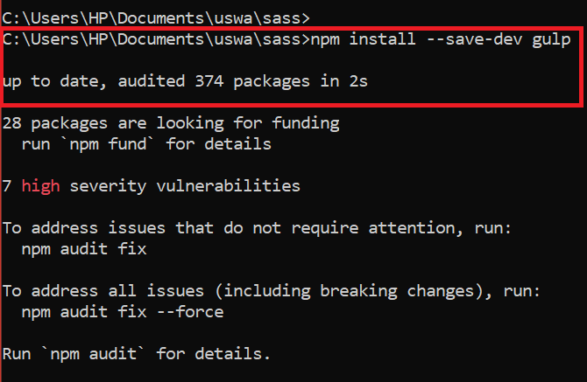

1. **Gulp Plugins Installation:**

The important plugins of Gulps that are used in this project are: gulp-sass, gulp-autoprefixer, gulp-clean-css, gulp-postcss.

**Plugins:**

**Gulp-sass plugin:**

This plugin converts SASS files to CSS. This is also called **Compilation**.

**Gulp-autoprefixer plugin:**

This plugin adds vendor prefixes to CSS rules for better browser compatibility. Vendor prefixes are necessary to ensure that CSS properties are interpreted correctly by different web browsers. This is also called **Autoprefixing**.

**Gulp-clean-css plugin:**

This plugin is used in Gulp workflows to minify and optimize CSS files. It reduces the size of CSS files by removing unnecessary spaces, line breaks, and performing other optimizations. This is also called **Minification**.

**Gulp-postcss plugin:**

This plugin is commonly used in Gulp workflows for optimizing and processing CSS files like gulp-clean-css plugin.

**Watch Task:**

The watch task monitors changes in SASS files and triggers the necessary tasks.

**Default Task:**

The default task (‘**gulp’**) initiates the ‘**styles’** task and the ‘watch’ task in series. This task is triggered when running ‘**npx gulp**’ in the terminal.

**Command:**

The command used to install these Plugins is:

“**npm install --save-dev gulp-sass gulp-autoprefixer gulp-clean-css gulp-postcss**”

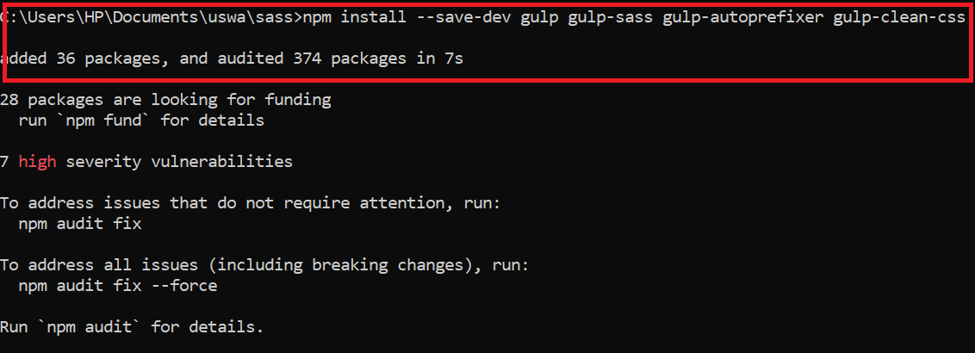

1. **Create files for project:**

* Create index.html in the directory in which package.json file is present.
* Create styles.scss file in the path as src/sass/styles.scss.
* Create images folder in the path as src/images.
* Also create dist named folder and in dist folder create css named folder.
* The purpose for creating the dist folder is: when the code will run, the scss code will be converted into the css code and css file will be stored in this folder.

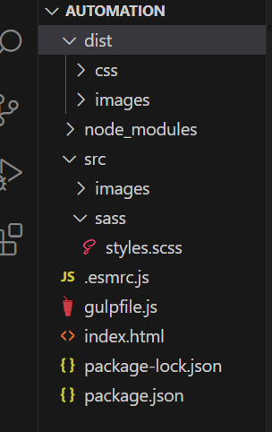

1. **Create a Gulpfile:**

Create a file named “**gulpfile.js**” in your project root to define Gulp tasks. Define Gulp tasks for SASS compilation, autoprefixing, and minification. The code of this file is:

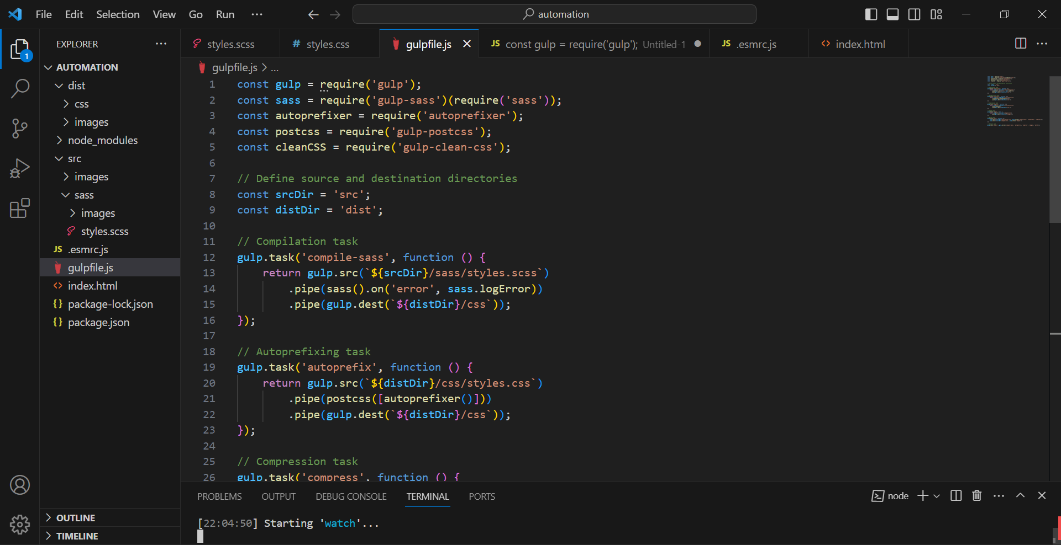

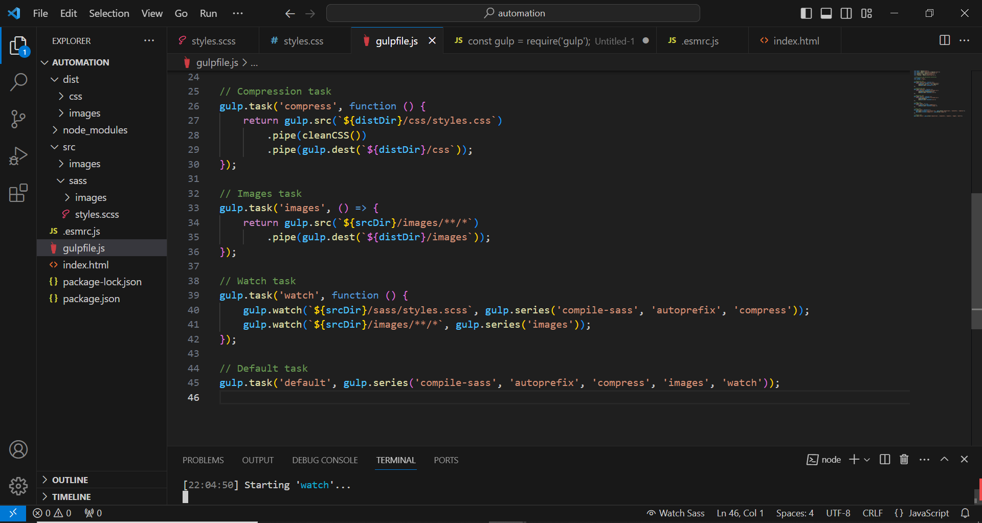

The **Gulpfile** is a configuration file for Gulp, a task runner for automating web development workflows. In this specific Gulpfile, tasks are defined to compile SASS files into CSS, **autoprefix** the CSS for cross-browser compatibility, compress the CSS for **optimization**, and **copy images** from the source directory to the distribution directory. The **watch** task is also configured to monitor changes in SASS files and images, triggering the corresponding tasks automatically.

1. **Run Gulp:**

* Execute the Gulp command to start the automation process:

“**npx gulp**”

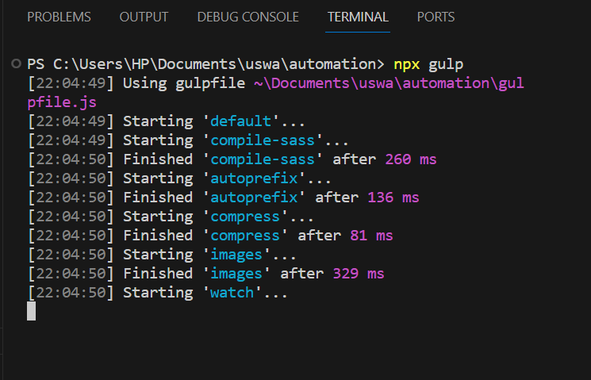

* When this execution command runs, the project start running as in picture.
* Then open index.html file on Browser and it will start running the website.
* It you update Scss code then save the file then the changes immediately appear on website.

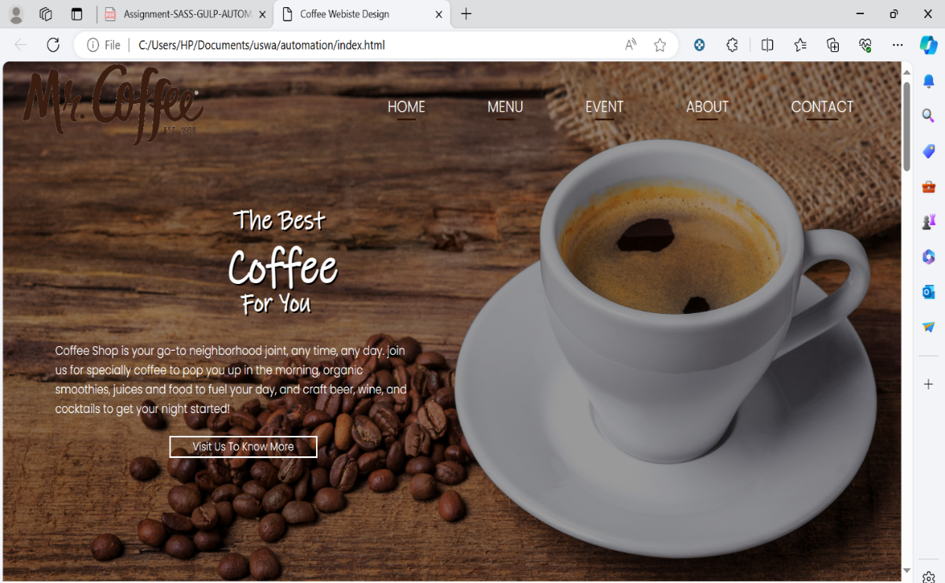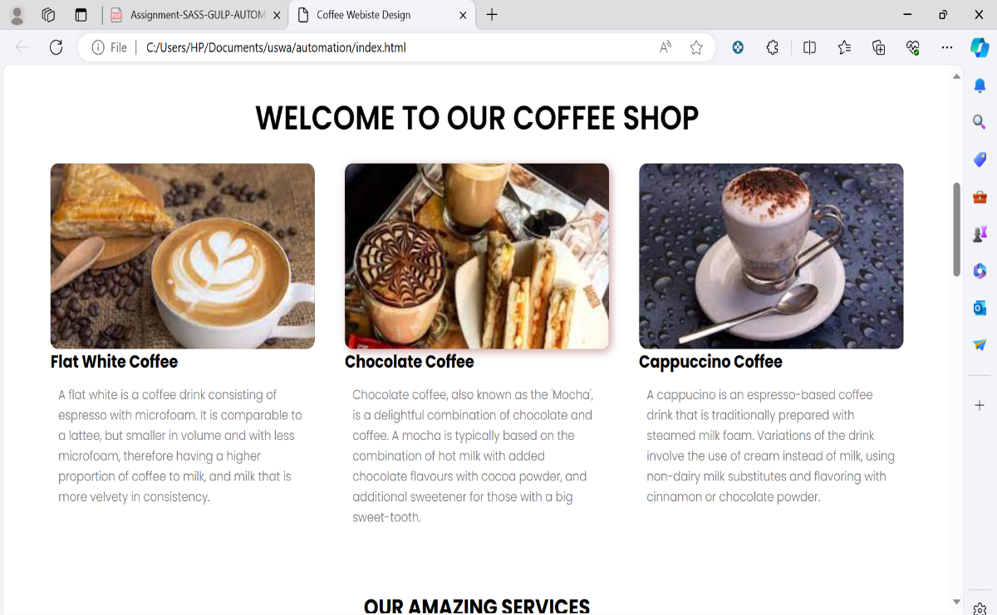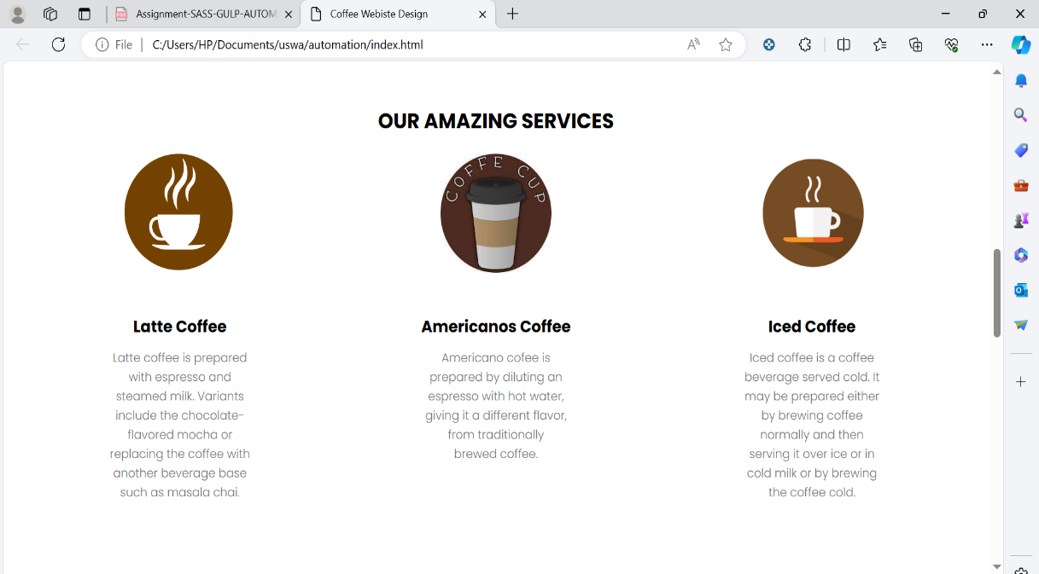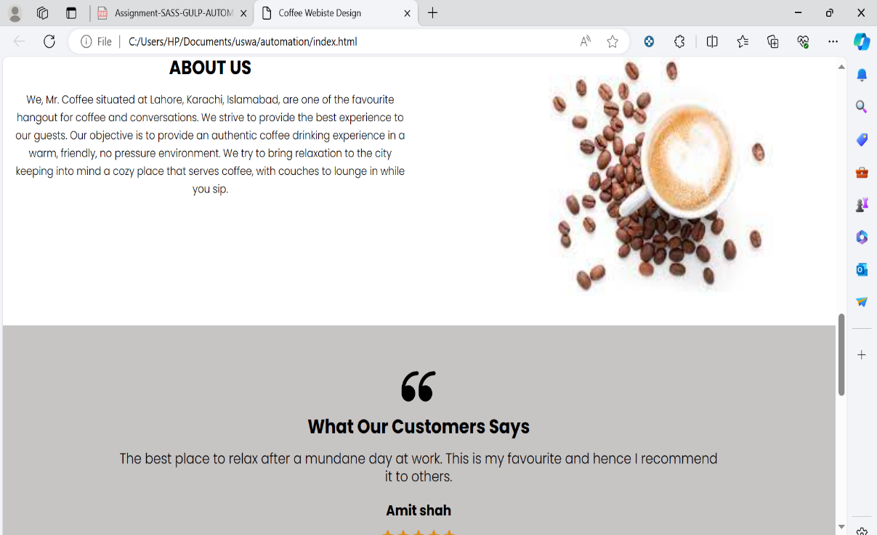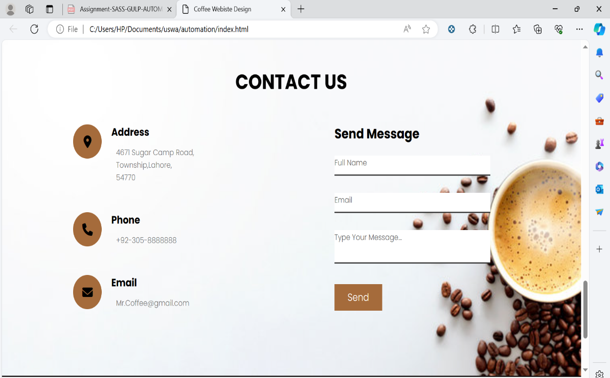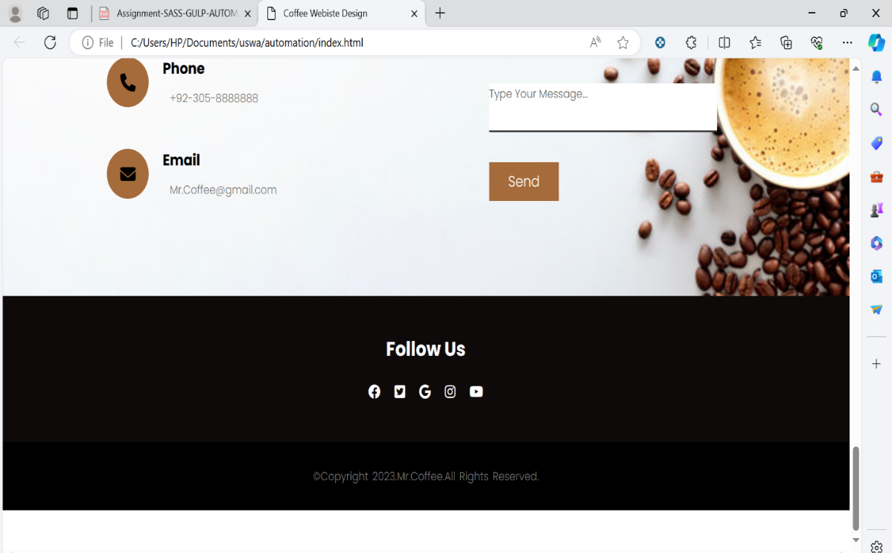

**Challenges Faced:**

1. **ES Module Compatibility:**

An issue with ES Module compatibility may arise when requiring Gulp plugins. This is addressed by using dynamic imports instead of “**require**”.

1. **SASS Compiler Selection:**

The default SASS compiler has been deprecated in newer versions of “**gulp-sass**”. The solution is to set the SASS compiler explicitly in the Gulpfile.

1. **Autoprefixer Reference Error:**

Ensure that the “**autoprefixer**” variable is defined within the Gulp task function to avoid reference errors.

**Conclusion:**

By following these steps, you should have successfully set up a SASS pipeline using Gulp. The pipeline automates the compilation, autoprefixing, and minification processes, enhancing the efficiency of your front-end development workflow.